DataSci Cleaning Data Lecture Notes – JSON

JSON

1. Stands for Javascript Object Notation
2. Lightweight Data Storage
3. Common format for API data
4. Smiliar structurally to XML, but different syntax and format
5. Data can be stored as
   1. Numbers (double)
   2. Strings (double quoted)
   3. Boolean (True or False)
   4. Array (ordered, comma separated enclosed in square brackets [])
   5. Object (unordered, comma, separated collection of key:value pairs in curly brackets{})
      1. Always opens with a curly bracket{}

JSON Examples

Source Code for github’s api of user’s repos such as https://api.github.com/users/mathaholic/repo

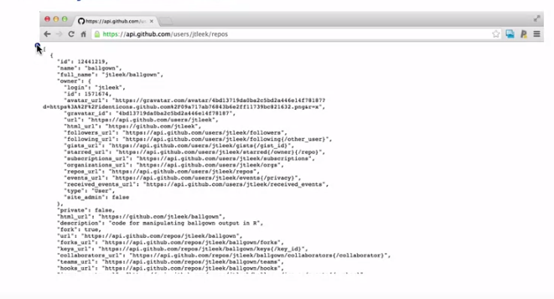

Reading JSON into R

1. Install.packages(“jsonlite”)
2. jsonData <- fromJSON(“filesource”), gives back a data frame
3. from there you can use commands
   1. name(jsonData) to see the names
   2. name(jsonData$stuff) gives back everything in that column
4. json can have data frames within data frames

Writing data frames to JSON

1. myjson <- toJSON(“filesource”, pretty = TRUE)
2. cat(myjson) prints the JSON files

Converting back to JSON

1. put the JSON file back into R
2. it looks like a data frame again. wooo